**Project Report:**

Daily count of the number of Elon Musk’s tweets vs. the day’s Tesla stock market price change (close - open)/open.

**EXTRACT (Data Sources)**

* Import CSV files using pd.read_CSV:
  + Tesla stock prices (CSV): <https://www.kaggle.com/rpaguirre/tesla-stock-price>
  + Musk Tweets (CSV): <https://data.world/adamhelsinger/elon-musk-tweets-until-4-6-17>

**TRANSFORMATION**

* Tweets:
  + Formatting tweet dates from date & time to date
    - Round time values in excel to 0 decimals
    - Format to mm/dd/yyyy
  + Calculated the count of tweets, grouped by date
* Stock:
  + Calculation of stock deltas (closing - opening)
    - Divide by opening price to calculate relative daily % change
  + Drop fields: high, low, volume, adj. close fields
* Joining:
  + Left join stock data frame with tweet data frame on dates
* Plot ‘bubble’ scatter plot of dates (x-axis), stock % change (y-axis) and # of tweets (z-axis).
* 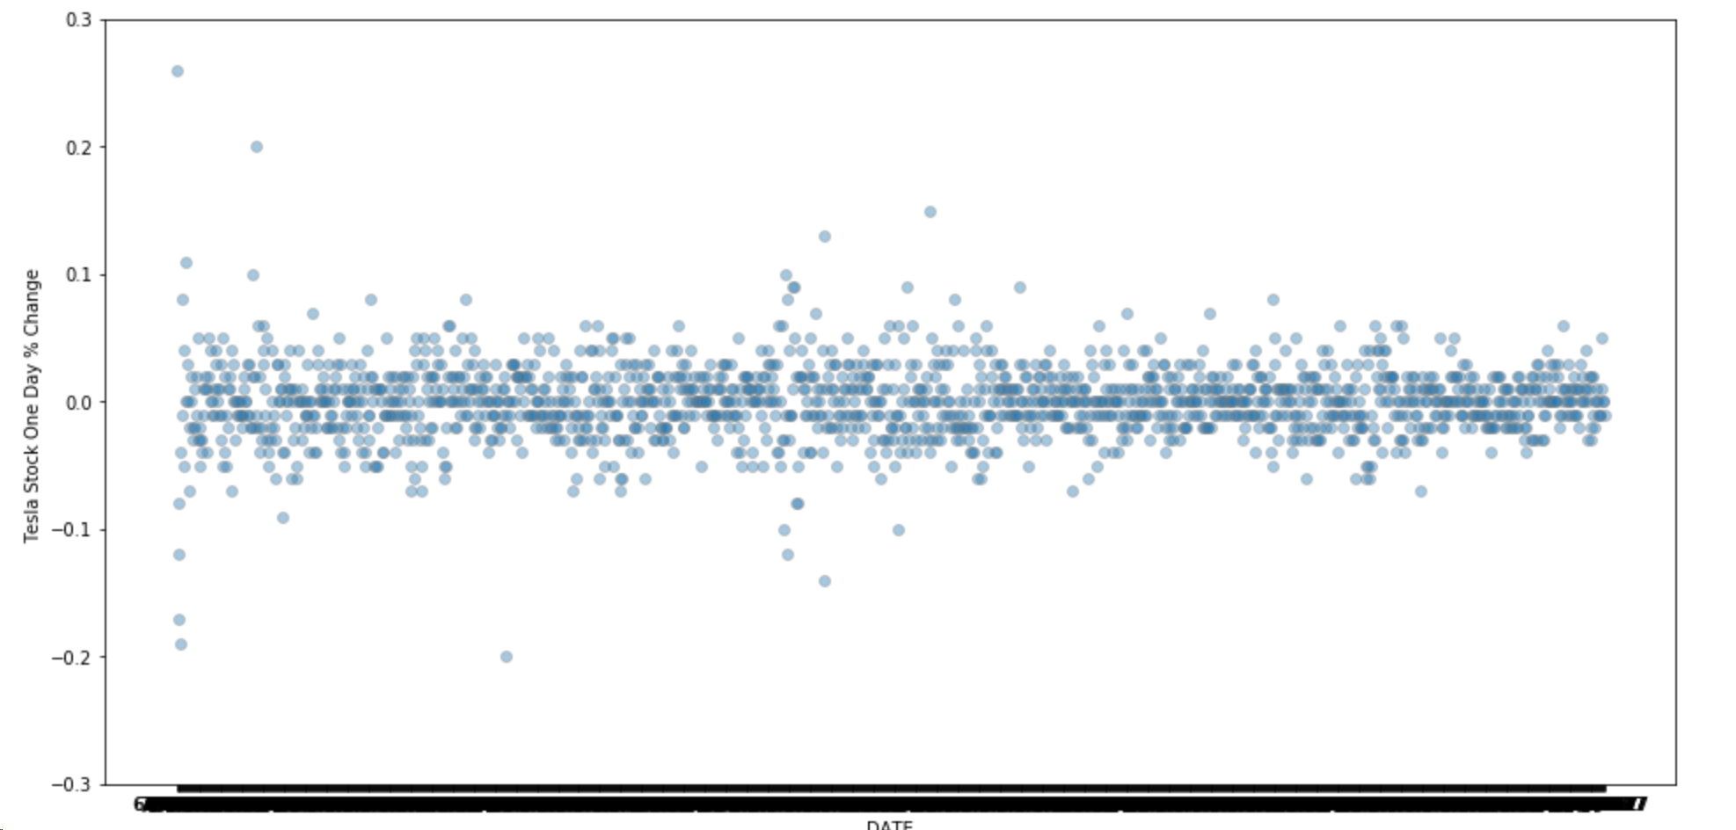

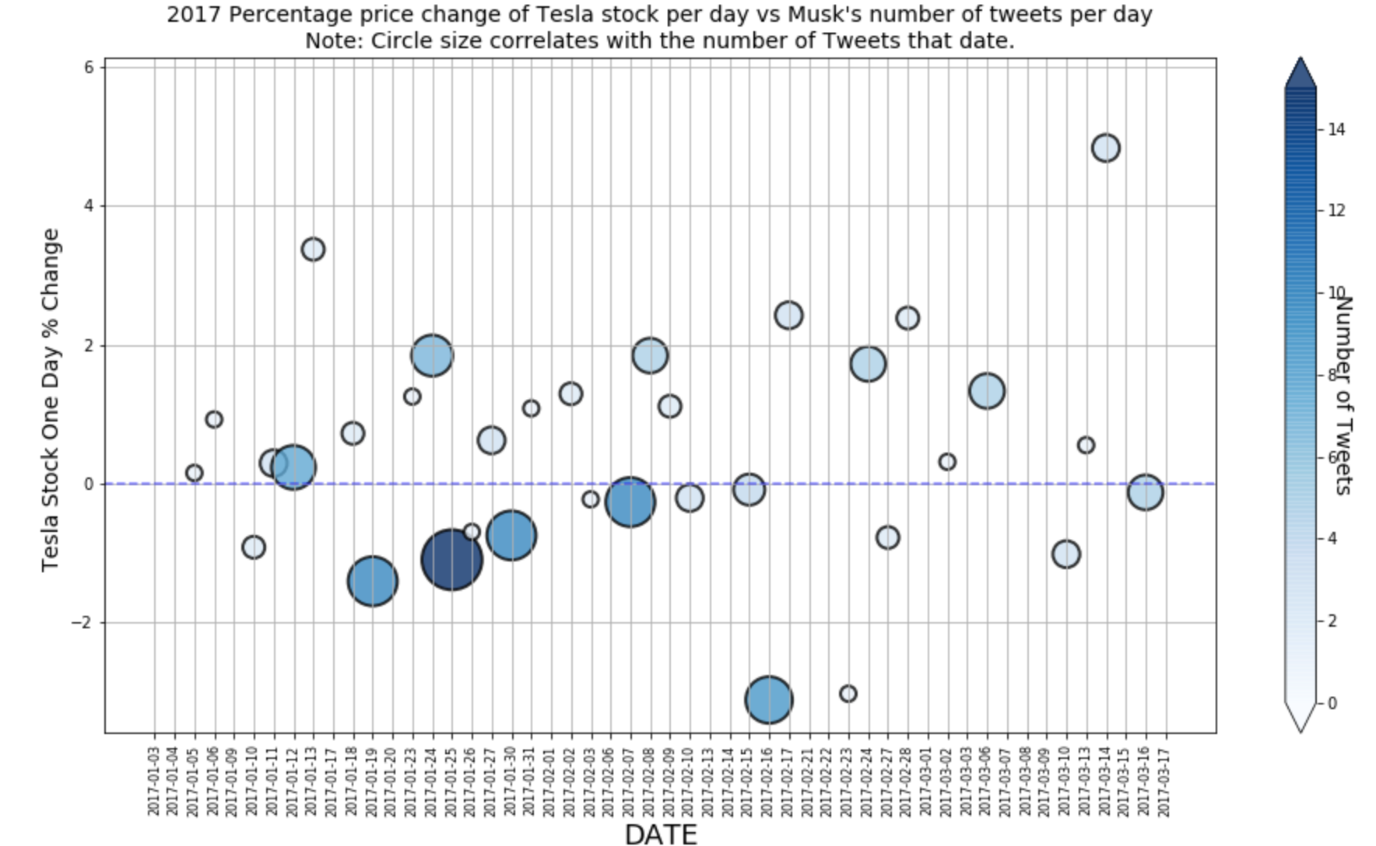

**LOAD**

The team selected mySQL to load the data transformation results. This decision was made as only one table was required to load the final results.

* Establish mySQL connection
* Create database named musk_db;
* Established local hose engine within jupyter notebook
* Used pd.read_sql to read select * from musk_db
* Loaded the merged data frame developed in jupyter notebook into mySQL using .to_sql

**Results**

Looking at the 2017 data, the plot shows higher tweet counts on days with negative stock price changes on days than on days with positive stock price changes, although there are many data points where the tweet count is low and the stock price change is positive. Our interpretation of this results is that these tweets could either cause stock changes or follow events that lead to such changes, and Elon could have both positive and negative impacts on the Tesla stock prices. Anecdotally, it also suggests Elon freaks out over twitter on days when Tesla stock isn’t doing well, for whatever reason (his own tweeting or otherwise).